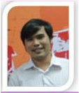

**Dr. HungPD**

**SUPERVIOR**

**ThanhLCM**

**PM/PL**

**DucHA**

**Developer**

**TrungTM**

**Developer**

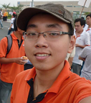

**CuongNT**

**Developer/Tester**

**KhoiMN**

**Tester**

